Chris Straschewski

CMS180014

CS 4395.001

System Description

* Created with Dialogflow Essentials
* NLP techniques were used in last program –
  + Webcrawler used to iterate through relevant Shrek-related URLs
  + Ultimate goal of this was to compile a list of the most frequent and important Shrek-related keywords
  + These keywords were used extensively on the Dialogflow chatbot.

Rough Chatbot Diagram

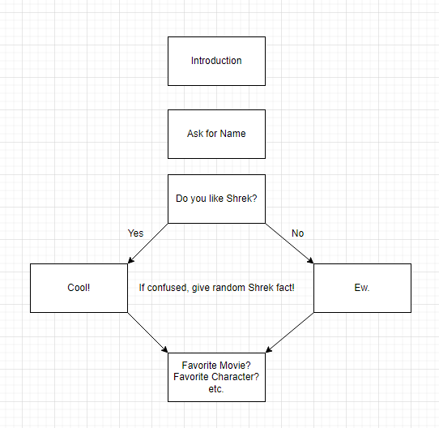

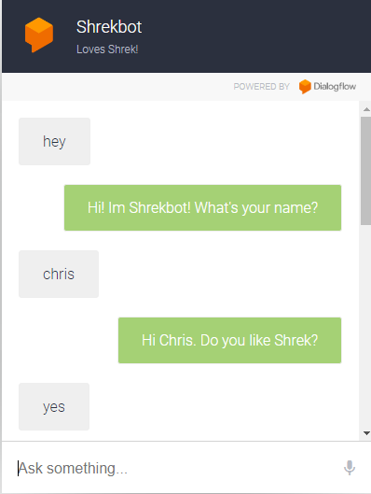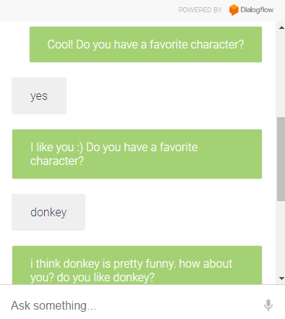Sample Conversation

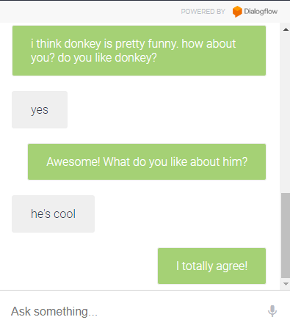

Chatbot Layout

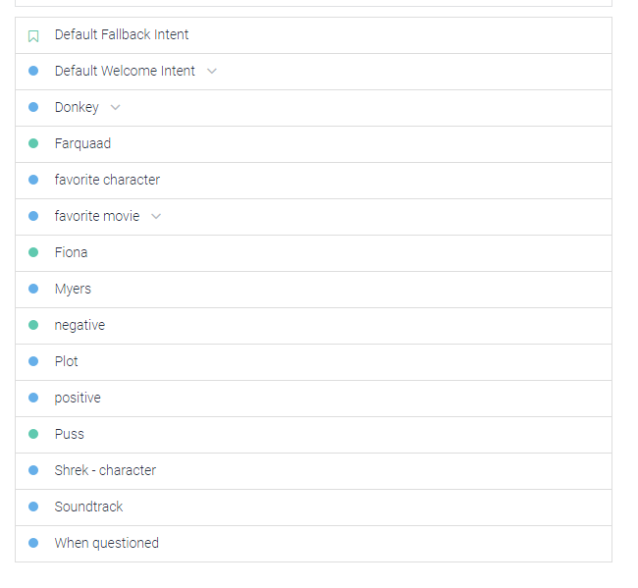

Evaluation

Strengths

* Knowledge of a decent variety of topics
* Friendly
* Keeps conversation going, especially at the beginning

Weaknesses

* Poor depth of knowledge regarding each topic
* Will sometimes just loop
* Just could use a lot of tweaking